

**Week 4:** Deployment on Flask

**Name:** Anitha Venkatachalam

**Batch Code:** LISUM14

**Date:** 21 OCT 2022

**Submitted to:** Data Glacier

**Table of Contents:**

1. Introduction ………...…………………………………………………….…….3
2. Build Machine Learning Model ………………………….…………………….5
3. Turning Model into Flask Framework ……………………………………...….6
   1. App.py ……………………………………………………………………...7
   2. Index.html …………………………………………………..……………...8

4.Running Procedure ……………………………………………………..…9

# 1. Introduction

In this project, we are going to deploying machine learning model using the Flask Framework. As a demonstration, our model helps to predict the values based on the input given in Iris Dataset.

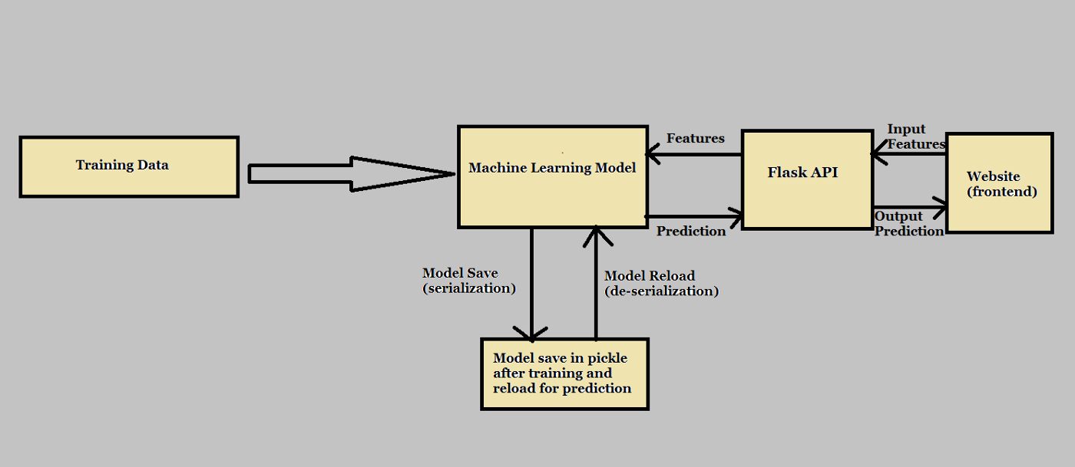

we will focus on both: building a machine learning model for Iris Dataset, then create an API for the model, using Flask, the Python micro-framework for building web applications. This API allows us to utilize predictive capabilities through HTTP requests.

#### 2. Building a Model

### 2.1.1 Import Required Libraries and Dataset

In this part, we import libraires and dataset which contain the information of Iris dataset.

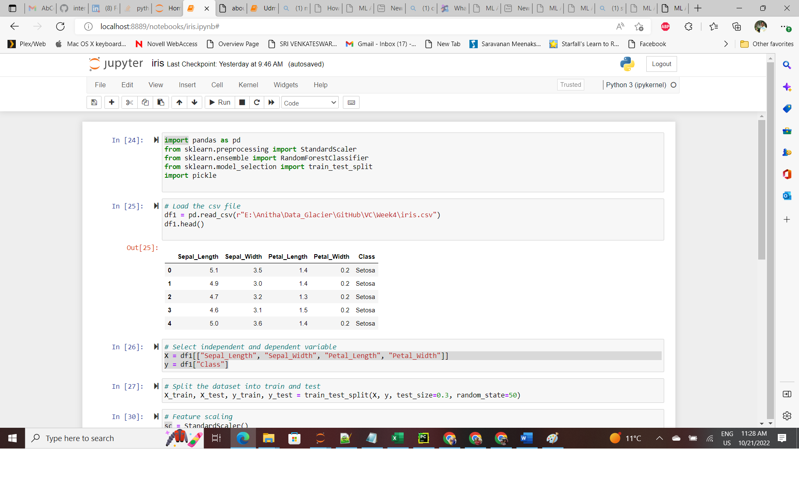

### 3.1.1 Data Preprocessing

The dataset used here is split into 80% for the training set and the remaining 20% for the test set. We fed our dataset into a Term Frequency-Inverse document frequency (TF-IDF) vectorizer which transforms words into numerical features (numpy arrays) for training and testing

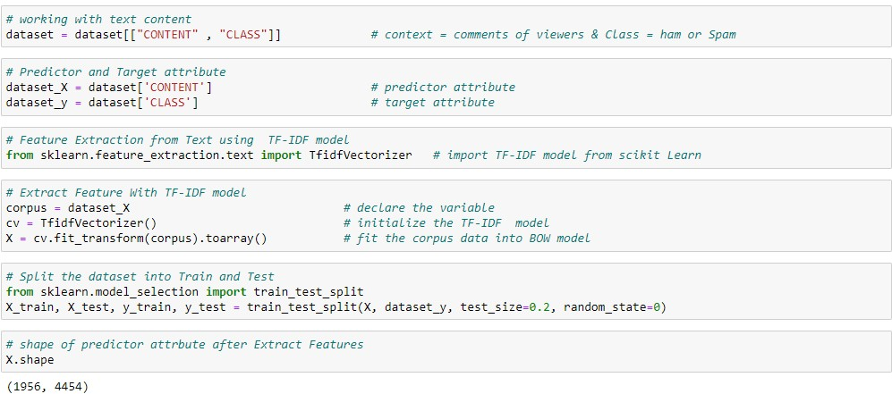

### 3.1.2 Build Model

After data preprocessing, we implement machine learning model to predict the iris value in the dataset. For this purpose, we implement Standard scalar using sklearn. After importing and initialize Standard scalar model we fit into training dataset.

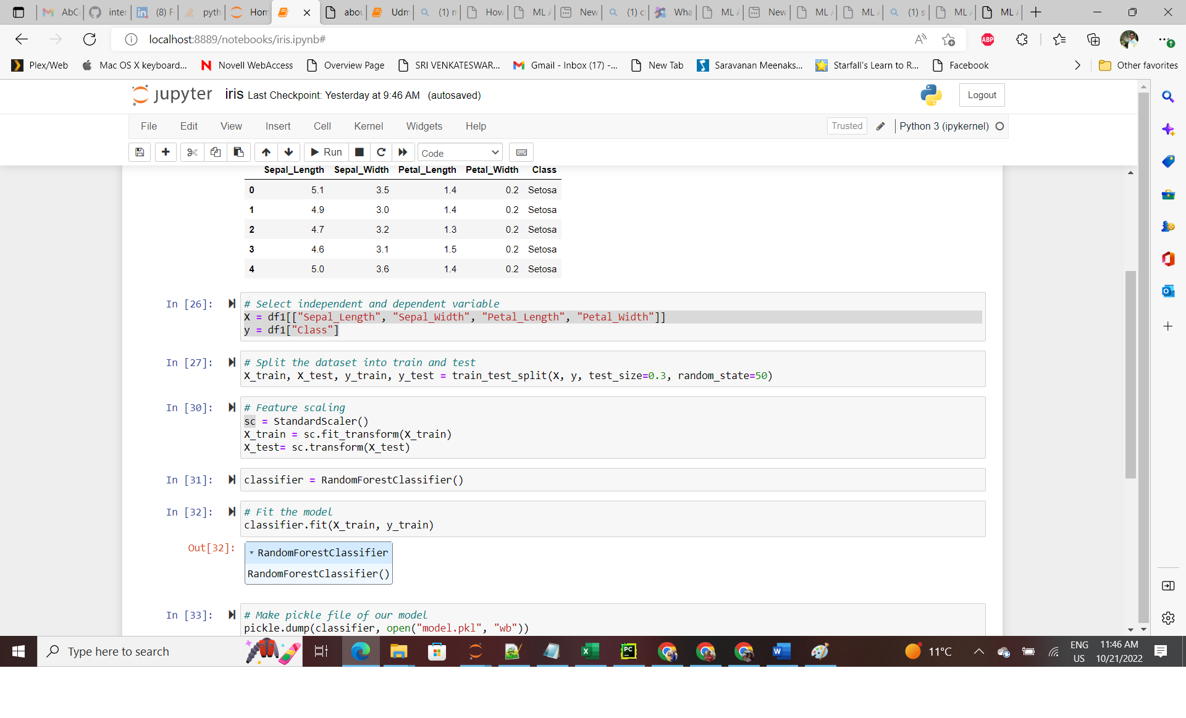

### 3.1.3 Save the Model

After that we save our model using pickle

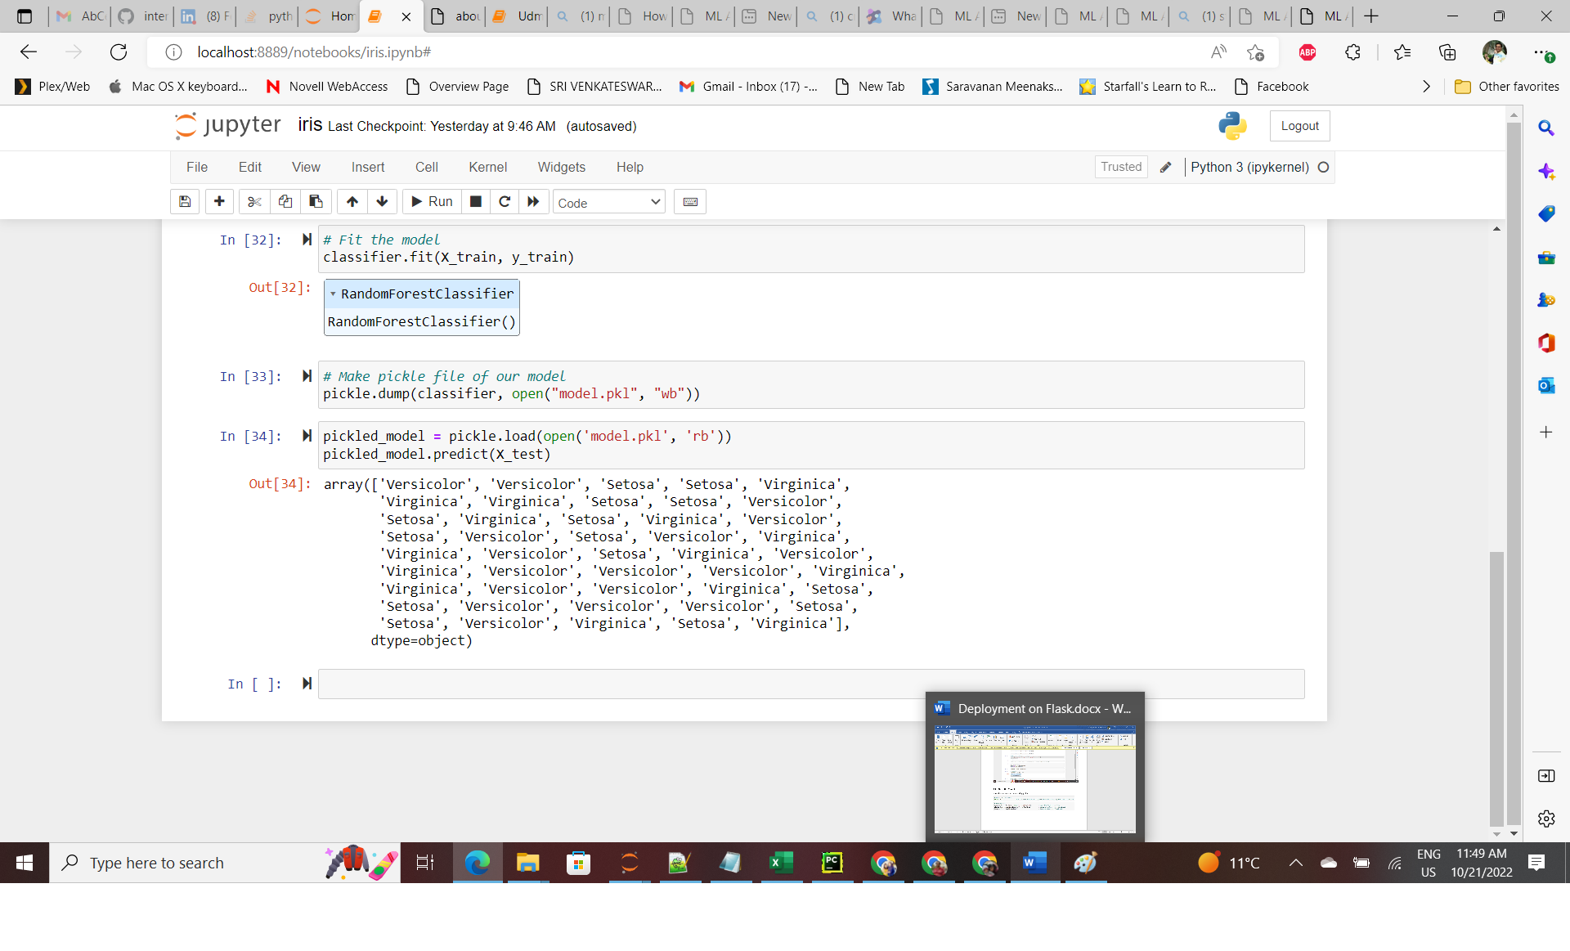

**4.Turning Model into Web Application**

We develop a web application that consists of a simple web page with a form field with entering the values and predict. After submitting the message to the web application, it will render it on a new page which gives us a result of Versicolor, Virginica.First, we create a folder for this project called Iris, this is the directory tree inside the folder. We will explain each file.

Table 3.1: Application Folder File Directory

|  |  |
| --- | --- |
| **app.py** |  |
| **Templates** | **Index.html** |
| **Model** | **model.pkl** |
| **Dataset/** | **Iris.csv** |

**3.1 App.py**

The *app.py* file contains the main code that will be executed by the Python interpreter to run the Flask web application, it included the ML code for classifying SD.

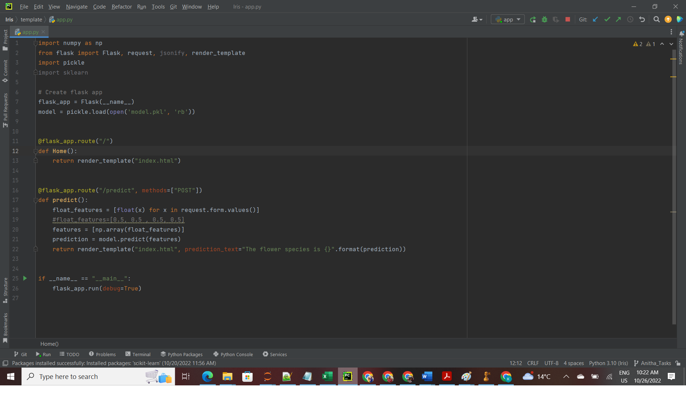

Figure 3.1: App.py

* We ran our application as a single module; thus, we initialized a new Flask instance with the argument *_name* to let Flask know that it can find the HTML template folder (*templates*) in the same directory where it is located.

• Our *home* function simply rendered the *Index.html* HTML file, which is located in the *templates* folder.

* Inside the *predict* function, we access the Iris data set, pre-process the values, and make predictions, then store the model. We access the new message entered by the user and use our model to make a prediction for its label.

• we used the *POST* method to transport the form data to the server in the message body. Finally, by setting the *debug=True* argument inside the app.run method, we further activated Flask's debugger.

• Lastly, we used the *run* function to only run the application on the server when this script is directly executed by the Python interpreter, which we ensured using the *if* statement with *__name__ == '__main__'*.

* **3.2 Index.html**

The following are the contents of the *Index.html* file that will enter the values to predict the flowers.

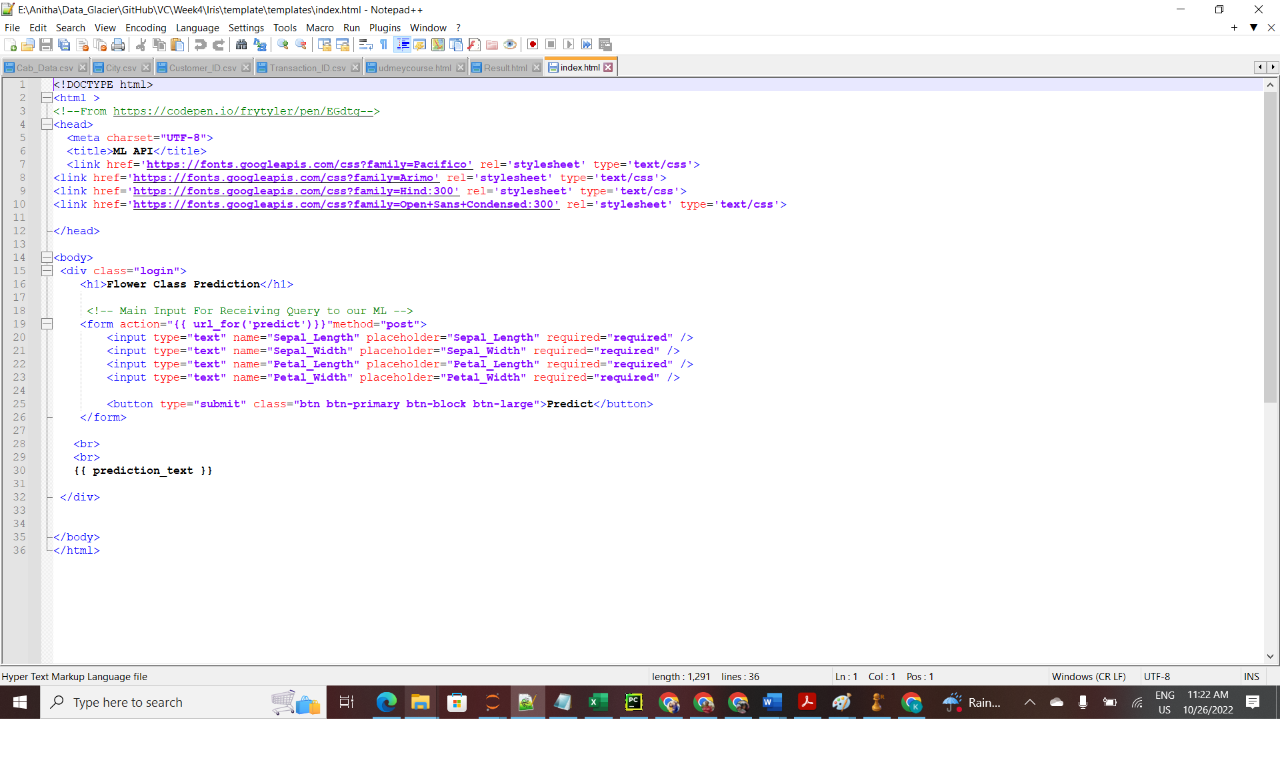

* **4.1.2 Running Procedure**

Once we have done all of the above, we can start running the API by clicking run button in *app.py* screen:

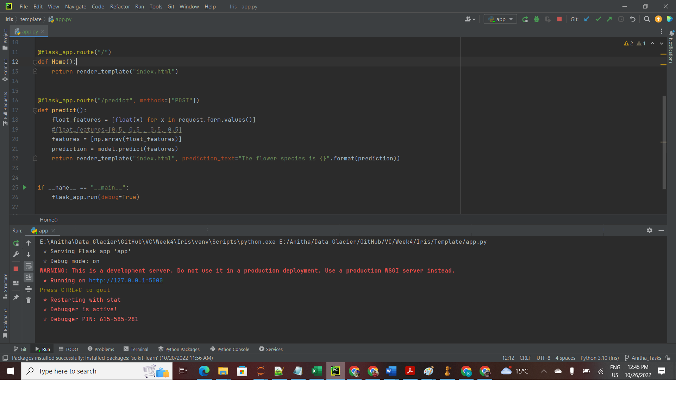

Now we could open a web browser and navigate to http://127.0.0.1:5000/, we should see a simple website with the content like so

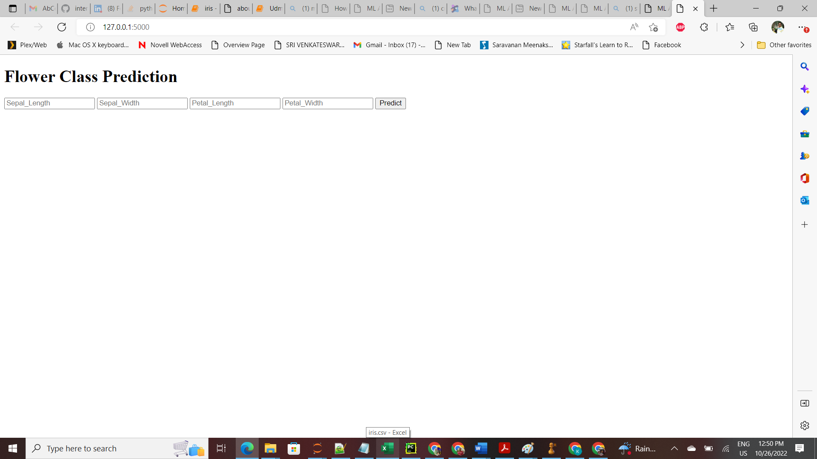

Now we enter input in the values in textbox and the value is predicted.

